Personalized cheque Printing Software Solution for Sri Lankan Banks

to

Lake house printers & Publishers.

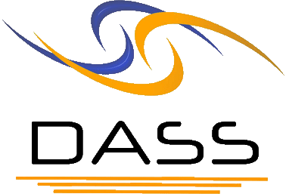

DA Software Solutions (Pvt.) LTd
Private and Confidential


DA Software Solutions (Pvt.) Limited.
#76, Pagoda Road, Nugegoda. Sri Lanka.
E-mail: dumindu@dassonline.com
Phone: +94 114 941 921, +94 773 435 429

19th November 2009

Mr. Rasika S. Karadawa
IT Administrator,
Lake house printers & Publishers,
Colombo 02.

Dear Sir,

QUOTATION for Maldivian Cheque Printing Software Solution for “BOC - Sri Lankan “

First and foremost, thank you very much for your interest in DA Software Solutions (Pvt) Ltd. With reference to your inquiry on the above software solution, we are pleased to submit herewith our price quotation for your kind consideration.

Pricing Summary

Create a solution for capture data from Tex File Rs. 175,000.00

Create a Cheque Print Software Solution - design & development Rs. 185,000.00

Special Discount for Lake house printers & Publishers Rs. (36,000.00)

Total cost of the Solution Rs. 321,000.00

Currency of Offer
All prices are in Sri Lankan Rupees.

Proposal Validity
This proposal is valid for a period of one (01) month.

Payment Terms & Other Charges

Application System Charges
50% - on confirmation of the quotation
50% - on completions prior to hosting

Training
User training will be done at site during the implementation.

Software Agreement
Software Agreement to be signed with “DA Software Solutions (Pvt) Ltd.”

Software Warranty
This software solution carries a warranty period of Six (06) months from the date of User acceptance test (UAT).

Software Maintenance
Maintenance services shall be provided under a maintenance agreement to be signed after the warranty period expires. The standard annual maintenance charges would be fifteen percent (15%) on the product price plus the subsequent cost of modifications.

Software Maintenance
Upfront 100% maintenance fees for a period of one year at the signing of the maintenance contract.

Any Software related faults, defects and malfunctions would be done free of charge after confirming the results which are related to the software. (After a review done to identify that it is not a hardware related issue)

Additional Software Modifications
All additional software modification charges will be quoted after a detailed system study. The development of the modifications would begin once a written confirmation is given by the client.

Modification Charges
Rs. 1,200 – Per Man Hour
Rs. 8,000 - Per Man day (9:00 am to 5:00 pm)
50% - on confirmation of the quotation
50% - on implementation of the modifications

Response Time
On receiving a complaint from Lake House printers & Publishers (Pvt) Ltd., if DA Software Solutions unable to resolve over the phone, e-mail or remote dial-up, attend to the problem on site within four (04) hours of such complaint within the City of Colombo.

Updates/New Modules
Customers under maintenance service agreement are entitled to free Application Updates within the same version, database, operating system, and application language (subject to application customizations done at the client’s site) of the modules purchased.
Other additional/new modules/new version upgrades would be available at a very special discounted price to your company.

Purchase Order & the Payments
Purchase Order and the payments to be issued to “DA Software Solutions (Pvt) Ltd.”

Some of our clients

Client Name User Reference Solution given

Citygroup Mr. Sumeda Karunarathne PDC – Data Converter Product Manager WHT-Splitter Solution

Printing Solution Ltd. Mr. V Umasudhan Smart Capture & Printing Chief Operating Officer Solution for “Tigo” Billing

Ceylinco Land Exchange Mr. Manjula Suraweera "Water-Billing"
Automation Solution

Ceylinco Savings Bank Mr. Dushmantha Weerathunga “Pawn – Brokering”
Manager IT Software Solution

Ceylinco Development Mr. Imdaad Nagiub “Pawn – Brokering”
Bank Manager IT Software Solution

Confidentiality
All material, prices and other information’s provided in this proposal and other supporting documents, annexure, CD-ROMs, diskettes etc. should not to be disclosed to any 3rd party without a written consent from DASS.

We hope this pricing proposal would meet your requirements. Should you need any further clarifications, please feel free to contact us.

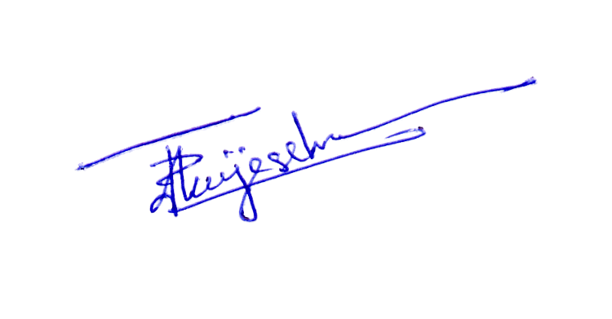
Thank You,
Yours sincerely,

D. Janeendranath Wijesekera
Director Business Development

